Create entire cluster –
Note – All commands beginning with ‘wsl -e bash -c’ are being run from VS on host(laptop). If you want to run same directly on Ubuntu{WSL) run only the command.
- Delete Cluster, If already existing -
wsl -e bash -c "kind delete cluster --name healthcare-cluster
- Check all prerequisites –
wsl -e bash -c "echo 'Checking prerequisites...' && echo '1. Docker:' && docker --version && echo '2. kubectl:' && kubectl version --client && echo '3. kind:' && kind --version && echo '4. istioctl:' && istioctl version --remote=false"
- Create Cluster -
wsl -e bash -c "cd /mnt/c/docker && kind create cluster --config kind-config-nodeport.yaml --name healthcare-cluster --wait 120s"
(Ensure name of kind config file is correct)]
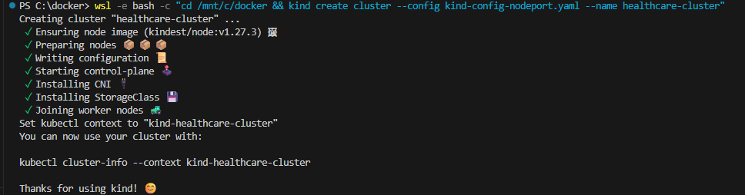
wsl -e bash -c "kubectl get nodes -o wide"
- Install Istio –
wsl -e bash -c "echo 'Installing Istio with demo profile...' && istioctl install --set values.defaultRevision=default -y"
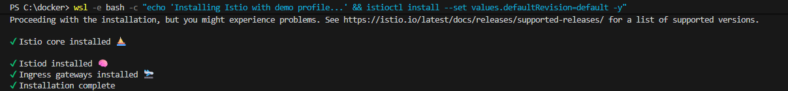
- Create namespace and enable istio injection –
wsl -e bash -c "echo 'Enabling Istio injection for default namespace...' && kubectl label namespace default istio-injection=enabled --overwrite && echo 'Creating healthcare namespace...' && kubectl create namespace healthcare && kubectl label namespace healthcare istio-injection=enabled"
Note - When you set the istio-injection=enabled label on a namespace and the injection webhook is enabled, any new pods that are created in that namespace will automatically have a sidecar added to them
- Setup Monitoring –
kubectl apply -f ../monitoring/kiali.yaml
Similar command as above is being used in shell script setup-monitoring.sh. This script installs and configures Prometheus, Grafana, jaeger and kiali. It also creates dashboards, setup alerts and port forwarding.
- Build and Deploy Images –
There is build-and-deploy.sh which does this activity but bellow are manual commands .
Lets quickly check all prerequisites are in place –
wsl -e bash -c "echo 'Step 6: Checking prerequisites manually...' && echo '1. Docker status:' && docker info | head -5 && echo -e '\n2. Kind clusters:' && kind get clusters && echo -e '\n3. Current kubectl context:' && kubectl config current-context && echo -e '\n4. Cluster info:' && kubectl cluster-info"
Pull base images and load in cluster –
docker pull mongo:7.0
docker pull postgres:15-alpine
kind load docker-image mongo:7.0 --name healthcare-cluster
kind load docker-image postgres:15-alpine --name healthcare-cluster
Build docker image and load it in cluster –
cd to the services/patient-service folder and run (Node.js) -
docker build -t healthcare/patient-service:latest .
kind load docker-image healthcare/patient-service:latest --name healthcare-cluster
cd to services/appointment-service folder and run (Python Flask) -
docker build -t healthcare/appointment-service:latest .
kind load docker-image healthcare/appointment-service:latest --name healthcare-cluster
cd to services/medical-records-service and run (Go) –
docker build -t healthcare/medical-records-service:latest .
kind load docker-image healthcare/medical-records-service:latest --name healthcare-cluster
cd to services/ healthcare-dashboard and run (React) –
docker build -t healthcare/healthcare-dashboard:latest .
docker-image healthcare/healthcare-dashboard:latest --name healthcare-cluster

- Deploy Kubernetes
kubectl apply -f k8s/base/namespace.yaml (wont do anything as we had earlier created ns)
ConfigMaps store non-sensitive configuration data like database URLs, service endpoints, and application settings.' && echo 'They allow us to separate configuration from code and easily update settings without rebuilding images.
kubectl apply -f k8s/base/configmaps.yaml
Secrets store sensitive data like database passwords, API keys, and certificates in encrypted format. They provide secure access to credentials without hardcoding them in containers or config files.
kubectl apply -f k8s/base/secrets.yaml
RBAC defines what actions each service account can perform within the cluster for security. It ensures services only have the minimum permissions they need to function properly.
kubectl apply -f k8s/base/rbac.yaml"
MongoDB provides document-based storage for patient data with flexible schema design. Includes persistent volume claims to ensure data survives pod restarts and scaling.
kubectl apply -f k8s/base/mongo.yaml"
PostgreSQL provides relational database storage for appointments and medical records with ACID compliance. Uses persistent volumes for data durability and includes initialization scripts for schema setup.
kubectl apply -f k8s/base/postgres.yaml"
Manages patient registration, profiles, and personal information with RESTful API endpoints. 'Connects to MongoDB for document storage and includes health checks for monitoring. kubectl apply -f k8s/base/patient-service.yaml"
Handles appointment scheduling, doctor availability, and booking management with Flask REST API. PostgreSQL for relational data and provides calendar integration capabilities.
kubectl apply -f k8s/base/appointment-service.yaml"
Manages medical history, diagnoses, treatments, and clinical data with high-performance Go backend. Connects to PostgreSQL for secure storage and provides FHIR-compliant data access patterns.
kubectl apply -f k8s/base/medical-records-service.yaml"
Provides web-based user interface for healthcare staff to access all microservices through a unified dashboard. Built with React and served by nginx with reverse proxy configuration for API calls.
kubectl apply -f k8s/base/healthcare-dashboard.yaml"
Check all pods and services –
wsl -e bash -c "echo 'Checking deployment status...' && kubectl get pods -n healthcare && echo -e '\nServices:' && kubectl get svc -n healthcare"
Istio Gateway defines how external traffic enters the service mesh through load balancers. Virtual Services configure traffic routing rules and load balancing between service replicas.
kubectl apply -f istio/"
Dashboard Gateway provides web interface access through Istio ingress with proper routing. Enables external access to the React dashboard while maintaining security policies.
kubectl apply -f k8s/istio/dashboard-gateway.yaml"
Check if istio and related stuff is deployed -
kubectl get gateways,virtualservices,destinationrules -n healthcare"

- Port forwarding –
Port forwarding creates tunnels from localhost to services running inside the Kubernetes cluster. This allows us to access internal services from our local machine for testing and development.
pkill -f
kubectl port-forward' || true && sleep 2"

kubectl port-forward -n healthcare svc/patient-service 3001:3001 --address=0.0.0.0 &
kubectl port-forward -n healthcare svc/appointment-service 3002:3002 --address=0.0.0.0 &
kubectl port-forward -n healthcare svc/medical-records-service 3003:3003 --address=0.0.0.0 &
kubectl port-forward -n healthcare svc/healthcare-dashboard 4000:4000 --address=0.0.0.0
kubectl port-forward -n istio-system svc/grafana 3000:3000 --address=0.0.0.0 &
kubectl port-forward -n istio-system svc/jaeger-query 16686:16686 --address=0.0.0.0 &
kubectl port-forward -n istio-system svc/kiali 20001:20001 --address=0.0.0.0 &
kubectl port-forward -n istio-system svc/istio-ingressgateway 8080:80 --address=0.0.0.0 &
Check port forwarding status - ps aux | grep 'kubectl port-forward' | grep -v grep
curl -s http://localhost:3001/health || echo 'Patient service not yet accessible'
Error – Patient service not yet accessible
Issue is Port 3001 works inside WSL but not accessible from Windows browser

- Port Forwarding –

setup-windows-networking.ps1 (Windows Port Forwarding)
Start-Process PowerShell -Verb RunAs -ArgumentList "-File", "C:\docker\scripts\setup-windows-networking.ps1"
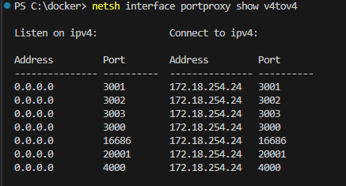
Purpose: Creates Windows netsh rules for WSL-to-Windows connectivity

What it does:
Detects WSL IP address automatically
Creates port forwarding rules for all healthcare services (3001-3003, 4000)
Creates rules for monitoring tools (3000, 9090, 16686, 20001)
When needed: CRITICAL - Required for accessing services from Windows browser

start-platform.sh (Advanced Port Forwarding)
wsl -e bash -c "cd /mnt/c/docker/scripts && ./start-platform.sh"
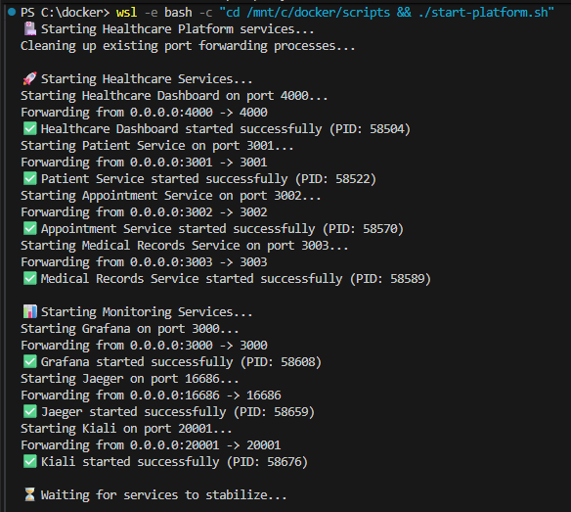
Purpose: Comprehensive kubectl port forwarding with health checks
What it does:
Manages all kubectl port-forward processes
Includes health checking and automatic recovery
Provides process management and cleanup
When needed: After Windows networking setup to establish WSL port forwarding.
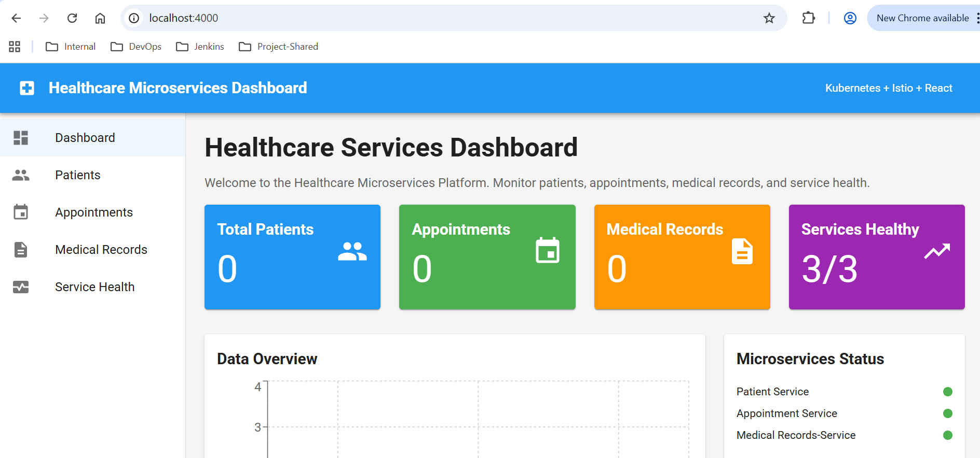

- Why Node port does not work
The issue is that Kind uses Docker network bridges that are isolated from the host. For NodePort to work with Kind from Windows, you need to access the Kind node IP addresses directly.
wsl -e bash -c "curl -s -o /dev/null -w 'Direct Node Access (Patient): %{http_code}\n' http://172.19.0.4:30001/health || echo 'Failed to connect'"
Finally, did not work and we switched to scripts above.

Checking logs and site can’t be reached issue -
kubectl logs -n healthcare deployment/healthcare-dashboard -c dashboard --tail=10"
kubectl logs -n istio-system -l app=kiali --tail=10"
-c is container name and -l is label selector to target pods that have the label app=kiali
Check port forwarding is running –
wsl -e bash -c "ps aux | grep 'kubectl.*port-forward.*4000' | grep -v grep"

If dashboard shows "site can't be reached", ensure port forwarding is running
- All 3 services should show as "healthy" (green) in the dashboard
- Check Windows port forwarding rules if needed: `netsh interface portproxy show v4tov4`

Cluster Architecture –
Key Architecture Highlights:
📊 Cluster Scale:
3 Kubernetes Nodes (1 control plane + 2 workers)
20+ Pods running across the cluster
4 Core Healthcare Services + monitoring stack
Istio Service Mesh with automatic sidecar injection
🏗️ Multi-Layer Architecture:
Windows Host → netsh port forwarding
Ubuntu WSL → kubectl port forwarding
Kind Kubernetes Cluster → Docker network isolation
Service Mesh (Istio) → mTLS + observability
Application Layer → React frontend + microservices
Data Layer → MongoDB + PostgreSQL
🔒 Security Features:
Automatic mTLS between all services (Istio)
RBAC with service accounts
Network isolation by namespace
Certificate management via Istio
📈 Observability Stack:
Grafana - Dashboards & visualization
Prometheus - Metrics collection
Jaeger - Distributed tracing
Kiali - Service mesh visualization (currently down)
🌐 Access Patterns:
Windows Browser → Services via localhost:300x
NodePort Access → Direct cluster access (30001-30004)
Service Mesh → Internal mTLS communication
Load Balancing → 2 replicas per service

